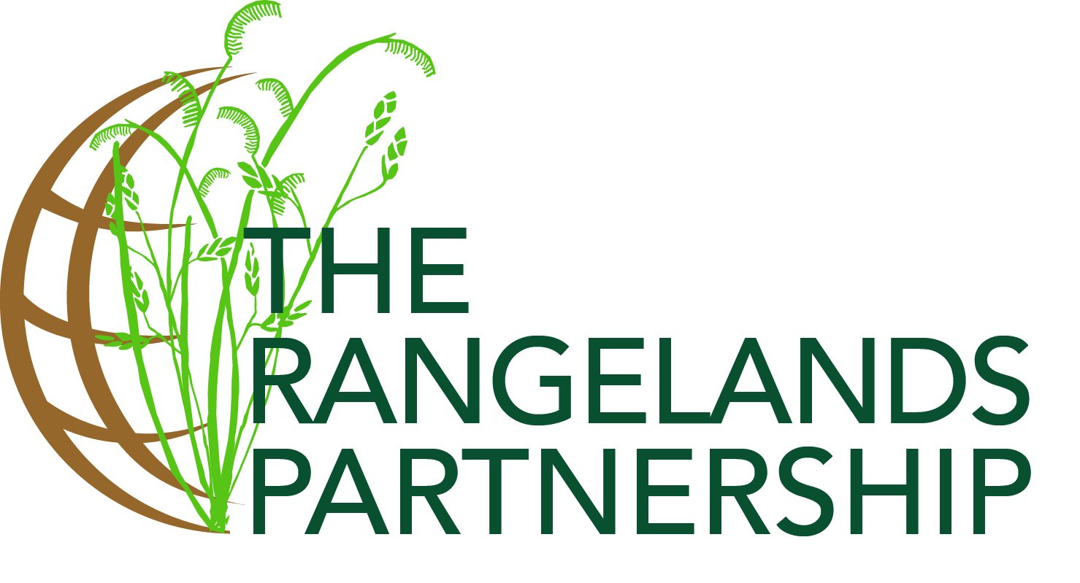
June 17, 2019

Secretariat of the Committee on Agriculture (COAG) of the
Food and Agriculture Organization of the United Nations,
Viale delle Terme di Caracalla
00153 Rome, Italy
Email: fao-hq@fao.org

Dear Sirs/Madams:
Re: Support to the request from the Government of the Mongolia for an International Year of Rangelands and Pastoralists
On behalf of the Rangelands Partnership, I am writing to present our members’ sincere regards to you and your esteemed office of the Food and Agriculture Organization of the United Nations. Indeed, the Rangelands Partnership is honoured to write in support of the request of the Government of Mongolia for an International Year of Rangelands and Pastoralists.
Our Partnership, a nearly 20-year collaboration of 19 land-grant universities in the United States, is fully supportive of the effort to gain a designation for an International Year of Rangelands and Pastoralists. To this end, we congratulate the Government of Mongolia on its leadership and on its excellent proposal. An International Year of Rangelands and Pastoralists will be a unique opportunity to raise the profile and support for critical rangelands and pastoral issues globally and nationally. The Rangelands Partnership is committed to improving the public’s understanding of the challenges and opportunities faced by rangelands and pastoralists throughout the world. Specifically, we believe the conservation of rangelands and support for the people whose livelihoods depend on them have a direct relationship to food security and a healthy environment.
With this in mind, please accept our support for the request of the Government of Mongolia for an International Year of Rangelands and Pastoralists.
Yours sincerely,
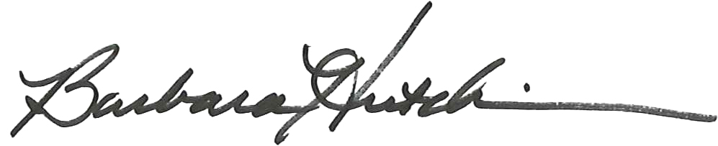
Barbara Hutchinson, PhD
Communications Manager, The Rangelands Partnership
School of Natural Resources & the Environment
College of Agriculture & Life Sciences
University of Arizona
Tucson, Arizona USA 85721
Email: bhutchin@email.arizona.edu

