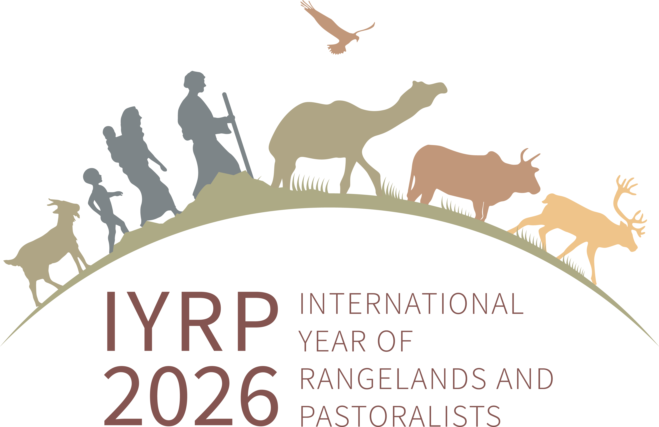
Minutes of RISG co-chairs meeting, 24 November 2022
Present: Igshaan Samuels (moderation), Ann Waters-Bayer (notes), Barry Irving (NA), Ken Otieno (ESA), Guodong Han (EA), Cecilia Turin (South America), Ruijun Long (EA), Hijaba Ykhanbai (CAM) Harouna Abarchi (WCA), Tatsama Motilal (South Asia), DK Sadana (South Asia), Serena Ferrari (WCA), Pius Loupa (ESA), Amélie Kauffmann (Europe), Andiswa Finca (ESA)
1. IYRP RISG coordinators list
Igshaan informed about some changes regarding co-chairs of the RISGs:
- Australasia: Sarah has stepped down; Dana is acting; new (co-)chair is still to be named
- ESA: Kedibone & Igshaan stepped down; Andiswa & Prisca joined as co-chairs from Southern Africa
- NA: David Borre joined in place of Jürgen Hoth
- South America: Cecilia Turin from Peru has joined as 3rd co-chair
- WCA: Discussions are underway about two new leading organisations.
The IYRP logo has been changed; now the animals and people are moving forward (to the right).
2. IYRP symposium at the SRM Conference at Boise, Idaho
Barry explained that there will be two events at the SRM (Society for Range Management) meeting in Boise, Idaho, in early February 2023: the IYRP symposium and a workshop on the IYRP. The symposium on 7 February 2023 is being organised by Igshaan, Maryam & Layne. Abstracts have been submitted and accepted. Global topics will be discussed but taking a bit of a North & South American focus. Cecilia will bring in a pastoralist from South America to speak during the discussion. The symposium will be 100% virtual, so no need to adhere to a strict timeline. It has been planned for 2 hours, with presentations of 10–15 minutes each, but that could be stretched.
To do: Barry to forward Layne’s email with draft programme to Ann to attach to minutes.
Cecilia: Pastoralist will record statement on video to be presented with English translation, because it is too difficult to have a pastoralist live online. Barry found this preferable, because then the input is certain (no connectivity issues).
Igshaan: Could pastoralists from other regions pre-record messages in the language of their choice?
Cecilia: Will someone from the Pastoralist Youth Forum or Dana+20 meeting be speaking? Barry did not believe so. Cecilia could contact those organisations to see if someone could speak, e.g. young woman from Sami reindeer herders.
To do: Cecilia to provide links to organisations that could identify pastoralists to invite to speak.
SRM is making 200 free (virtual) tickets available for the IYRP symposium and the rest of the SRM meeting (another 3 days). The symposium will be recorded. Virtual registration will give access to the recording for up to one year. Barry suggests opening up the registration first to those who want to be online at the time of the conference, then open up to others who want to see the recording later. The registration link should be shared through the RISG co-chairs.
Igshaan: How can we make sure that we have 200 IYRP people to attend? The time difference may be too large for the Asian and Australasian RISGs. Better to focus on regions in time zones where it is easier to take part, e.g. Latin America, Africa, Europe.
Participants indicated that, nevertheless, some people from Asia will try to attend, and people from ESA will certainly join. Three of the speakers in the IYRP symposium come from ESA.
To do: Barry to share registration link for RISG co-chairs to circulate to their groups.
To do: Barry to check with SRM staff and determine the preferred way the link for free virtual seats will be disseminated.
Igshaan: There appears to be no moderator named yet for the sessions 7 and 8 when pastoralists will be speaking. Who could handle this task?
To do: Barry to ask symposium organisers to nominate someone to handle the moderation role.
3. Proposed global pastoral gathering
When RISGs contributed to the document on reaching out to pastoralists, a suggestion was made to organise a global pastoralist gathering in a process that involves pastoralists as much as possible in IYRP activities. Barry and Ann suggested holding such a gathering together with an already occurring international event, such as the UNCCD COP to be held in Mongolia in 2026. Hijaba said he would need to clarify what form such a gathering could take, e.g. as a pre- or side-event of the COP.
To do: Hijaba to explore potential for organising a global pastoralist gathering together with the UNCCD COP 2026 in Mongolia.
Cecilia: It is very challenging to bring together pastoralists because it is difficult for them to leave their families and animals, but that is one reason why they are not very visible. It would be important to make the considerable efforts that would be needed to hold a global gathering of pastoralists from all regions.
Ann and Igshaan suggested seeking collaboration with FAO (UN organisation handling IYRP 2026), IFAD (International Fund for Agricultural Development, which has already held pastoralist gatherings), the Dana Initiative, ICCA Consortium and WAMIP, among others, to start planning this.
Ken suggested planning backwards from 2026, with regional efforts to embark on the conversation leading up to a culmination at global level. Ann thought that each RISG should incorporate this activity into its regional planning in the years leading up to 2026. Loupa drew attention to the annual pastoralist gatherings that are held in several countries in Eastern Africa; these could be used to celebrate the IYRP and organise a global pastoralist event. Serena mentioned the regional gatherings that are held in the framework of the Global Agenda for Sustainable Livestock (GASL), which could also be included in the collaboration. Cecilia and Hijaba agreed that there should be national and regional gatherings before the global one in 2026.
Barry: The International Rangelands Congress (IRC) in Australia in 2025 might be another potential global meeting to consider for a pastoralist gathering. Igshaan suggested this might be for pastoralists in the Australasia region. Han thought that the best time for a global gathering might be indeed at the IRC2025.
Igshaan highlighted how difficult and costly it would be to bring in people from so many remote places around the world. Volunteers from each of the RISGs would be needed to raise wider interest and substantial funding for such an event, working together with partner organisations already mentioned. He will put this on the agenda of the next meeting of RISG co-chairs, which will be in early 2023. In the meantime, the RISGs can have conversations with different people/organisations that might be interested and come up with ideas to be shared during the next meeting.
To do: Igshaan to check with Dana Kelly about possibility of holding a regional or global pastoralist gathering at IRC2025.
4. Proposal to gain deeper insights into pastoralists’ understanding and interpretations of the terms ‘Rangelands’ and ‘Pastoralists’
Igshaan: There have recently been email discussions on what we mean by the terms “rangelands” and “pastoralists”; they have different connotations attached to them, and many local and indigenous peoples (IPs) do not relate to them. It has been difficult to get IPs on board to support the IYRP, as they don’t regard themselves as pastoralists or regard their land as rangelands. It was even suggested that the IYRP has started off on the wrong foot by separating rangelands from pastoralists. A proposal was made to ask pastoralists what they call themselves and their land. The process would show that their perceptions are appreciated and could increase their interest in the IYRP. The terms to be sought to make the existing word clouds for “pastoralist” and “rangeland” were identified mainly by North Americans. We should develop word clouds reflecting pastoralists’ own perceptions.
Ann: The two word clouds were based on their frequency in literature, but to find the terminology used by pastoralists, a different approach would have to be taken, not based on published materials.
Barry: There will be no one word that resonates with everyone. It is better to keep the definitions as general as possible. Rangelands are greater than pastoralists, as some rangelands are not used by pastoralists; and pastoralists are greater than rangelands, as they use more areas than only rangelands. “Rangeland is a type of land, not a type of land use.” SRM promoted this sentence for a while but it never really resonated. Perhaps it is time to promote it once again. Rangeland is an English term, so can be translated by the regions into local languages and perhaps even local dialects. Ken, Han and Loupa found this to be an interesting reflection. Cecilia: In Peru, rangelands and pastoralists come together.
Igshaan: How to change the methodology and come up with several word clouds that reflect the perceptions of pastoralists and other people in the rangelands?
Tatsama: We struggled to understand rangelands in the South Asia context. In India alone, we came up with 30-40 different terms for rangelands. We agreed within India that all these terms make up “rangelands”. If all countries supporting the IYRP (currently 102) did this, it would be a huge cloud.
Igshaan: It is best to try at country or subcountry level to understand how pastoralists view themselves and their land; then we could think of how to bring this together in a broader message.
Ken: This is a conversation largely between scientists. Pastoralists on the ground are not discussing what defines rangelands and pastoralists. Some range ecologists want to define open land for both wildlife and livestock as opposed to land exclusively used by pastoralists; the definitions are used to define who/ what is included or excluded.
Igshaan: These definitions are therefore important for decision-making related to policies.
Ken agrees with a process of engaging pastoralists at different levels about their perceptions of themselves and their land, culminating in a global gathering in 2026, when these perceptions can be debated and some agreement may be reached.
Harouna: In WCA, the most common language of pastoralists is Fulfulde. If we want to reach them, we must translate into Fulfulde. There are many words in Fulfulde for pastoralists and rangeland.
Serena: The main objective of the word clouds is to help people on the ground identify themselves as pastoralists, making communication materials about what international stakeholders mean by the terms “pastoralists” and “rangelands” and translate these materials into many different languages for the local, national and regional level.
Loupa: Understanding key terms is important in the current debate about conservation, pastoralism and rangelands, and whether pastoralism can co-exist with conservation. Conservation policy in Africa is not compatible with pastoralism, but pastoralists see themselves as conservationists. A bundle of rights (access, ownership, use, control) is key to understanding rangelands along with pastoralism and conversation. Each pastoralist group has its own way of defining rangelands. In Uganda, it is said to be a grazing area for wildlife and domestic animals.
Han: There are all kinds of terminology in different regions and different languages. The words “rangelands” and “pastoralists” convey a broad meaning for some kind of land and the people who use it, what kind of vegetation is included in rangelands and how can this be used for livestock production. It is important for people in different countries to understand what we have in common.
Igshaan as summary: It has been tried at country level in India to collect the many terms and thus gain insights into local understandings. These terms can be used in IYRP outreach materials to include the local people. The mapping exercises lead to greater understanding for those who are not pastoralists, e.g. conservationists. Such local terms should be gathered at national level; if pastoralists gather at the global level, this could be a point on their agenda. We ask Tatsama and other South Asia RISG members to share their methodology with the other RISGs. If country groups or individuals want to use a similar methodology, they can use the identified terms in IYRP materials disseminated at the respective levels.
To do: Tatsama to share with other RISGs the methodology used in India to collect local terminology.
5. Fundraising for RISGs to increase pastoralists’ participation in IYRP
Jürgen, Maryam, Anders and Hijaba were working on a strategy to raise funds to help reach out to pastoralists in remote areas to ensure their access to information, as part of securing their timely and full participation in the IYRP process. They asked the RISGs about needs for reaching out to key pastoralists groups in each region; 9 of the 11 RISGs responded. Igshaan raised the question: How to raise funds at regional and global level to respond to these needs?
Igshaan mentioned that Maryam and others in the Global Coordinating Group tried to raise funds – in this case for working groups to develop policy briefs and other science-based materials – by developing a proposal for SNAPP (Science for Nature and People Partnership) and sent in a concept to check its applicability, but they did not receive a favourable response.
Tatsama: In the South Asia RISG, we are using mainly human resources (volunteering) but need a dedicated person to coordinate communications. We reached out to some organisations in India for funding, but the response was very low. We sent out letters to Indian State Governments to generate support for the IYRP, but not funding.
Ruijun: In China, we are trying at 3 levels: i) in the highlands, by making IYRP-related inputs into government documents; local government are educating about improving pastoralism in highlands; ii) for trans-border events, particularly with Mongolia, but there was no response from Mongolian partners for this funding opportunity; iii) at global level: last week he had a 2-day meeting at ICIMOD (International Centre for Integrated Mountain Development) headquarters in Nepal about setting up a High Asian Pastoralism Network; this could be used as a platform to leverage some funds.
Loupa: Possible funding sources in ESA would be IGAD (Intergovernmental Authority on Development), USAID and NGOs and community-based organisations (CBOs).
Ann: To help raise funds for the Dana initiative, we approached a church-based donor (Misereor), through which it is relatively easy to get small funds for specific events; and also through individuals who are very supportive of pastoralists. If there are several organisations in a region that want to join forces to raise awareness and need to fund someone for communications, that may be possible through contributions from each of the organisations, e.g. CELEP (Coalition of European Lobbies for Eastern African Pastoralism) operates on membership fees paid by the member organisations.
Serena agreed about getting organisations to contribute to a dedicated person. In WCA, they are trying to reshuffle leadership, giving it to the main regional pastoralist organisations, RBM & APESS, to share resources, using people who speak both French and English and can provide coordination capacity; these organisations would be contributing with physical resources to the IYRP work.
Loupa: The IYRP should have a resource mobilisation coordination team. Igshaan: A global working group could supply the necessary information for RISGs that want to raise funds, advise in resource mobilisation and play a coordination role. Resources could be physical, such as outreach materials. Participants agreed with the idea of a resource mobilisation coordination team at global level.
Igshaan suggested that such a team could be created with representatives from each region, who would develop ideas and coordinate the IYRP fundraising efforts. These could work together with Igshaan and/or Maryam and/or Ann. In response to Serena’s question about the purpose for which the funds would be used, Igshaan explained that the main idea was to get pastoralists more involved in IYRP activities. The team would decide how the funds will be raised and how they will be used.
To do: Each RISG to name one person to be part of the IYRP global resource mobilisation team.
6. Any other business
Amélie Kaufmann (standing in for Oliver, co-chair of the Europe RISG) expressed an interest in learning more about the IYRP; Igshaan suggested that she communicate directly with him about this.
Igshaan thanked all 11 RISGs for submitting their regional updates; the compiled report will be disseminated soon via the International Support Group e-list and be posted on the IYRP website (www.iyrp.info). He reminded the RISGs to update their regional webpages so that as many people as possible can be informed about their activities. This being the last RISG co-chair meeting this year, he wished everyone a festive season and thanked all for giving so much support to the IYRP initiative.

CAM Central Asia & Mongolia, EA (East Asia), ESA Eastern & Southern Africa, NA North America, WCA West & Central Africa
Correction by Maryam Niamir (08.12.22): The ISG was invited to suggest words through a survey. About 80 members of the ISG responded and they were from all over the world. The only limitation was that it was in English, but that does not mean that it was confined to North America.
Correction by Maryam Niamir (08.12.22): It was done through a Google search (the full Google, not Google Scholar); therefore it reflects everything and not just literature.

