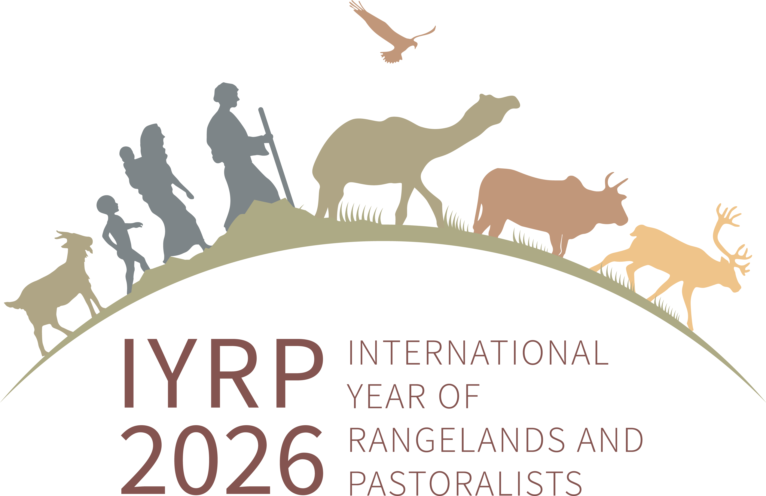

**Structure of IYRP coalition**

**Global Communications Team**

**Regional IYRP Support Groups (RISGs)**

**Working Groups:**

- Afforestation

- Desertification & Land Degradation

- Gender

- Mountains

- Water

**Global Coordinating Group (GCG)**

~40 members (co-chairs, comms team, RISG chairs & reps from key supporting partners (FAO, Govt of Mongolia, ILRI, IUCN, UNEP, WAMIP)

**General IYRP e-list**

~715 addresses mostly for info only

**International Support Group (ISG)**

~385 addresses of active partners, including GCG members and two co-chairs