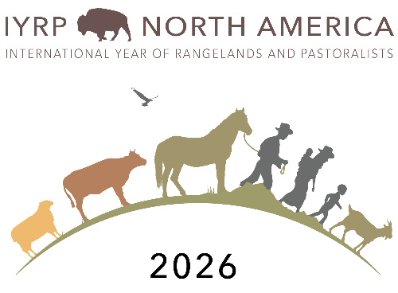
IYRP North American Communication Team
AGENDA
Meeting: October 31, 2022 12pm PDT

Organization into sub-groups
- 1: Social Media: headed by Elena
- 2: Documentary Film: headed by Barb
- 3: Film Festival: Headed by Courtney
- 4: Outreach and extension: headed by Lauren
- 5: Conferences- track upcoming conferences and who is going, as well as who presents IYRP things- we still need a team lead for this! Alejandra and Diego
- 6: Fundraising and contacting supporters: Still need a team lead. Identify what hired position would look like and how to get money to fund it. Maybe this is something we need to engage with the IYRP NA support group on.

- Do we want any other subgroups?
- Have members sign up for activity they want to help with, smaller sub-groups can meet to work on action items within the different sub-groups
New Meeting format idea: Plans on way to shorten meeting
- Update from each sub-group
  - Each sub-group leader provides short write-up on activities of their group.
  - Update is presented at the meeting: Each group gets 5 minutes for update/ discussion
- Google- Doc
  - A living document- include write up from each sub-group leader.
  - Anyone can add additional thoughts to a sub group section or to a section at the end for discussion topics to be added in the next meeting
  - Give all members 1 week to put in any thoughts into google-doc, and then it will be finalized and sent out to all members
  - Hope this will help engagement from quieter voices, and those unable to attend meeting
  - Would an excel file work- Lauren is going to try Excel format for agenda in November
Walk through the google drive:
- Link to Google Docs folders - https://drive.google.com/drive/folders/1TaB8Q8QgPazV38u5j1Td27-LMNIQdvkI

Other Topics
- Social Media
- Information from Barb on International Year of Soil
  - Find funding to hire someone part time? Full time. What would be cost? What would be tasks?
- Other updates?

Notes from meeting:
Alejandra: can we write up email to send around to our different societies to get them engaged? Yep, great idea.

Diego: can we add people to the main meeting email list or just subgroups? Both! Let’s get people involved in any way we can. Right now I just copy and paste the email list in so maybe it would be worth us thinking about creating a listserv. Does anyone know how to do that?

Peg: will write up different events in Canada coming up (date, name, contact person and location)

Elena: tagging our social media will help to make things more efficient.

