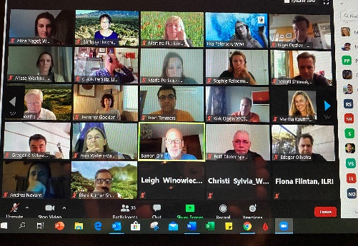**WWF Launches Global Grassland and Savannah Platform - July 21st, 2020 (summary report by Barb Hutchinson)**

Members of the **World Wide Fund** **for Nature (WWF)** organized a virtual meeting to discuss “how to accelerate the urgency to protect, sustainably mange, and restore grassland and savannah ecosystems and to set up a multi-organizational *Global Grassland and Savannah Dialogue Platform*.” Fifty participants from 18 countries joined in this first meeting. Members of the WWF set the stage with three overview presentations that provided the basis for a concluding discussion on ways forward. Three invited speakers offered more in-depth views on specific topics.

At the outset, there was recognition that the last 20 years have focused largely on forest ecosystems and that grasslands (including rangelands) have been neglected with damaging consequences. At the same time, it is estimated that while 40% of the world’s land area is designated “grassland”, these areas are facing large-scale conversion with up to 50% already converted in the Cerrado of Brazil as well as the Northern Great Plains, and with less than 10% protected globally. Key factors for demonstrating the importance of these lands included: biological diversity, carbon storage, freshwater, livelihoods & food security, and cultural identity. Two workstreams were proposed for improving and restoring the ecosystem services provided by these biomes to nature and people:

* Elevate these biomes to highest level of international attention
* Deliver on-the-ground interventions in specific landscapes to protect, better manage, and restore these biomes, especially models for broader sharing.

In outlining the possible framework for a “Global Grassland Ecosystems Dialogue Platform”, the following suggested focal areas were made:

* Establish targets and activities for the platform
* Exchange knowledge and insights
* Share lessons-learned from practical approaches
* Update on grassland ecosystem maps
* Position these ecosystems in global policies such as Global Biodiversity Framework
  + Develop clear indicators
  + Improve data coverage and timeliness
* Cooperate on side events at high-level conferences (UNGA, IUCN WCC, UNEA, CBD, UNCCD, UNFCCC)
* Develop joint science/policy papers
* Cooperate on potential funding opportunities.

Invited presenters included Maria Eugenia Periago (FVSA): Defining Valuable Grasslands Areas – Methodology and Challenges; Fiona Flintan (ILRI): Mapping as a Tool for Contributing to the Filling of Data Gaps in Grasslands and Savannas; and Sophie Reinermann (DLR): Assessment of Grassland State, Production, and Management Based on Remote Sensing. These presentations demonstrated the current lack of consistent and up-to-date data as well as a lack of agreed on terminology.

The concluding discussion gave participants the opportunity to comment on the ideas and concepts presented as well as to express interest in collaborating through the Platform. A few points brought forward included:

* feed into UN Decade of Ecosystem Restoration and the effort to gain an International Year of Rangelands and Pastoralists (raising visibility globally; decide on key messages)
* need for clear guidelines, definitions and to raise all functional properties including soil
* importance of terminology and incorporating human element
* challenge of turning science into good messaging
* build from local level to develop standards that can be taken to national and international levels
* need indicators for grassland health, i.e. seasonal variation
* create a toolbox of options (with harmonization; incorporated into SDGs)
* develop global tool to monitor rangelands/grasslands with people at center
* identify key biodiversity areas globally.

There was enthusiastic support for holding monthly meetings, particularly to dive deeper into issues and opportunities. A suggestion was made to begin putting together one-to-two page papers on different topics as soon as possible. The need to act now was widely held by the participants. A recording of the meeting and the presentations will be made available soon.