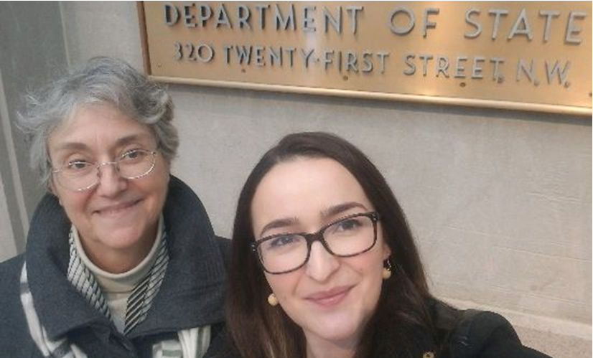
The Society for Range Management (SRM) – D.C. Update – January 30, 2020
On Monday, SRM's Lia Biondo and Maryam Niamir-Fuller met with the U.S. Department of State regarding the ongoing efforts to designate an International Year of Rangelands and Pastoralists. Maryam currently serves as the Vice Chair of IYRP Support Group but spent a lifetime living and working in Kenya with the United Nations Environmental Programme (UNEP).
To recap: Beginning in early 2016, many organizations began working together to gain support for a United Nations designated International Year of Rangelands and Pastoralists (IYRP). This led to the formalization of an IYRP Steering Committee that has spearheaded this effort by actively engaging with colleagues and interested parties around the world. The Steering Committee has coordinated numerous meetings and events and has worked with members to gain the support of their respective governments for the IYRP. One important event brought particular attention to this effort.
The United Nations Environment Assembly conference held in Nairobi in May of 2016 (UNEA-2) included a Side Event on “Sustainable Pastoralism and the Responsible Consumption of Livestock”. The outcome of UNEA-2 was a successful resolution “Combating desertification, land degradation, and drought and promoting sustainable pastoralism and rangelands”.
While this resolution did not include a provision for an International Year, it did include language calling upon organizations around the world to “contribute to raising the awareness of sustainable pastoralism and rangelands.” It also called for a worldwide gap analysis related to rangelands issues which was recently completed (links below). In addition, a special "Ministerial Breakfast" event was held on 12 March 2019 at UNEA-4.
Most recently, the Mongolian Government presented a request for an IYRP designation at an open session of the October 2018 COAG meeting in Rome, and it was formally supported by Ethiopia. Now Mongolia is leading the effort to gain additional country-level support for a formal resolution to be presented at the 2020 COAG Meeting
Our focus now is to gin up letters of support from other countries and international entities for the international years designation - approximately 25 support letters have already been received so far. SRM is pleased to host representatives from Kenya that will present a short video on these efforts at the Business Meeting in Denver.
For more information on the International Year of Rangelands and Pastoralists proposal, please click HERE.

