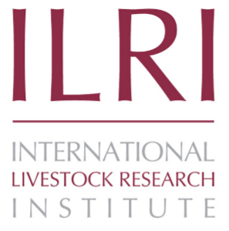
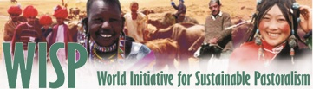

Calling for Support
to designate an
International Year of Rangelands & Pastoralists

A growing worldwide network acknowledges that the condition and productivity of the world’s rangelands and grasslands are critical to a sustainable future for people everywhere. Unhealthy and unproductive rangelands and grasslands destabilize countries, endanger national security, compromise economic productivity, and rob our youngest generation of opportunities for a prosperous future. To increase knowledge and understanding about these unique ecosystems and the people who rely on them, we urge you to join the effort to gain a United Nations resolution to designate 2021 as an International Year of Rangelands and Pastoralists!

Justification
Nearly half of the Earth’s land surface is classified as rangeland and grassland, and the health and productivity of these lands are critical to the livelihoods of an estimated 500 million people around the world. Increasing the understanding of the importance of these lands to global food security and environmental services, and calling attention to the need for sustainable management and enlightened policies in both developed and developing countries, will benefit not only those who gain economic sustenance from them today, but also future generations.

Pastoralists and other people who derive their livelihoods from rangelands and grasslands play a key role in their management. As stated in the background statement for the “Transformations toward sustainable pastoralism in drylands: UNEA-2 side event”, pastoralists are both livestock herders and environmental stewards of rangelands. Thus, sustainable pastoralist practices are critical to achieving food and water security as well as resilient local and national economies, and to addressing environmental concerns such as carbon sequestration, biodiversity conservation, and protection of land and ecosystems.

Yet, many forces threaten the productivity and ecological integrity of these lands and the human communities that rely on them. Common threats in both developed and developing countries include: unsustainable grazing practices, crop land expansion into areas best suited as rangeland, breakdown of common property regimes, land fragmentation, generational succession and rural exodus, damaging fire regimes, invasive plants, and harmful subsidies and policies. Pastoralists are among the poorest and most marginalized in many developing countries, where rural services barely reach them. Mobile pastoralists such as nomads and transhumant herders face discrimination and conflict. Products derived from rangelands such as meat and milk face intense competition from commercial, intensive livestock systems. Given changing climatic conditions and legal rulings, public health concerns, economic uncertainties, and controversies over land use, there is an urgent need to increase public awareness of the need to restore, maintain, manage, and make informed decisions about these landscapes and livelihoods. At the same time, the scientific and policy communities must be mobilized to attack these challenges with renewed vigor and creative energy to identify practical and strategic solutions.

Accomplishments at UNEA-2
- UNEA-2 President, Dr. Oyun Sanjaasuren (Mongolia), several Environment Ministers, and many other eminent people, called for support for a United Nations International Year of Rangelands and Pastoralists (IYRP) designation.
- Highly successful and informative Side Event was held on “Sustainable Pastoralism and the Responsible Consumption of Livestock” with many countries, pastoralists, and researchers expressing support for an IYRP.
- PASSED: UNEA-2 resolution “Combating desertification, land degradation, and drought and promoting sustainable pastoralism and rangelands”, calling among other things for raising global awareness and conducting scientific research, starting with a gap analysis of existing data and information on rangelands and pastoralism http://www.unep.org/about/sgb/cpr_portal/Portals/50152/UNEA%202/24.pdf.

A Quick Look at Outreach Plans for an International Year of Rangelands and Pastoralists
- Joint International Rangelands and International Grasslands Congress
- Launch of results of the UN global assessment/gap analysis on rangelands and pastoralists
- Social media campaign and video productions to raise awareness of producers, consumers, and policy makers in both developed and developing countries
- Private sector and industry support for sustainability in the livestock sector
- Pastoralist gatherings sponsored by World Initiative for Sustainable Pastoralism (WISP) and the FAO Pastoralist Knowledge Hub to share and document local knowledge and strategize practical solutions
- A possible conference on Sustainable Development Goals and their impact on pastoralists and rangelands, bringing together environmental, social, and economic aspects in an integrated vision
- Policy resolutions presented to the UN General Assembly

Proposed Next Steps in Designation Process
- Continue to raise awareness at grassroots in both developed and developing countries, including identifying key events leading up to and during the IYRP
- Raise global awareness at the Convention on Biological Diversity (CBD) Conference of the Parties (COP 13) in December 2016
- Determination of countries to take forward a formal request to the UN for an IYRP
- Engagement at UNEA-3 in 2017 to support FAO/UNGA processes

Support for United Nations Goals
This “call for support” builds on the attention the United Nations has given to economic, social, and environmental issues for sustainable development. Established 15 years ago, the UN Millennium Development Goals put a focus on targets to eradicate extreme poverty and hunger and ensure environmental sustainability, among other goals. Healthy and productive rangelands and grasslands contribute to improved livelihoods and environmental vigor.

The UN Convention to Combat Desertification (UNCCD) urges “development and implementation of national and regional policies, programmes, and measures to prevent, control and reverse land degradation and mitigate the effects of drought through scientific and technological excellence, raising public awareness…, thereby contributing to poverty reduction.” Improved pastoral systems can reverse the destructive effects of drought and create economic opportunity for rural populations.

The ambitious “2030 Agenda for Sustainable Development” substantiates and expands on these earlier frameworks with specific goals for sustainable agriculture, water management, sustainable energy and economic growth, combating climate change, and promoting sustainable use of terrestrial ecosystems. Healthy and productive rangelands and grasslands throughout the world are intrinsically linked to the successful realization of these goals.

Contacts for more information: (also please visit http://globalrangelands.org/international-year-rangelands-and-pastoralists-initiative)
Maryam Niamir-Fuller, Senior Advisor, Sustainability, UNEP
mniafull2@gmail.com
Barbara Hutchinson and Lovina Englund, Society for Range Management & The Rangelands Partnership
barbarah@cals.arizona.edu; lovina@uidaho.edu
Fiona Flintan, ILRI/International Land Coalition
f.flintan@landcoalition.info
Gabriel Oliva and Jim O’Rourke, International Rangelands Congress
geoliva@speedy.com.ar; jorourke@csc.edu
S. Ray Smith, International Grasslands Congress
raysmith1@uky.edu

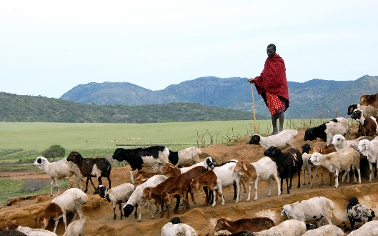
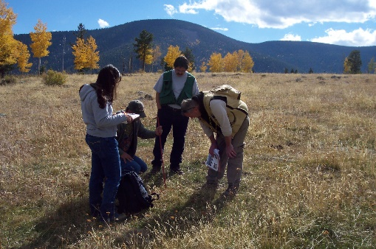
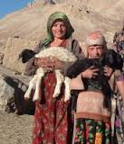
People Planet Prosperity Peace Partnership

Rangelands are grasslands, shrublands, woodlands, wetlands, and [cold and hot] deserts that are grazed by domestic livestock or wild animals. (Wikipedia, July 29, 2016 - https://en.wikipedia.org/wiki/Rangeland).
People who raise livestock or wild animals on extensive rangelands, including ranchers, nomads, and transhumant herders. (IUCN/UNEP 2014 - http://cmsdata.iucn.org/downloads/wisp_green_economy_book.pdf)

