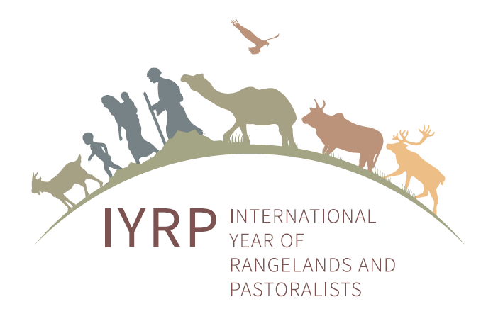
International Year of Rangelands and Pastoralists (IYRP):
information for pastoralist organisations

What is the IYRP?
In August 2019, the Government of Mongolia – a traditionally pastoralist country – proposed that the United Nations (UN) declare an International Year of Rangelands and Pastoralists (IYRP).
The UN designates specific years as times to promote a particular topic through awareness-raising and other activities. For example, the year 2024 has been named the International Year of Camelids.
In early October 2020, the Committee on Agriculture (COAG) of the Food and Agriculture Organization (FAO) endorsed the Mongolian proposal for a Year devoted to the topic of rangelands and pastoralists in 2026.
Why was an IYRP proposed?
In its proposal, the Government of Mongolia argued that over half of the Earth’s land surface is rangeland: areas where the vegetation is made up of natural grasses and shrubs that are grazed by livestock and wildlife. The productivity and environmental health of rangelands are critical for the livelihoods and cultures of more than 500 million pastoralists (see explanatory box “To make things clear”). Billions more non-pastoralists benefit from these areas through animal products, tourism, wildlife and biodiversity conservation, renewable energy and other uses and services.
The Government of Mongolia wants an IYRP to be celebrated so that more people in the world – especially policymakers – recognise the great value of rangelands and pastoralists and gain a better understanding of how these contribute to the economy, environment, society and culture at national and global level. An IYRP could raise awareness of the challenges and opportunities of life in the rangelands, including the need for access to health and education services, access to production inputs and markets, security of land-use rights, conflict resolution and investment in improving the rangelands. The IYRP could call attention to the need for better policies in and between countries worldwide to favour pastoral production systems.
Who is and can be involved in the IYRP?
The Government of Mongolia drew up the proposal in partnership with national and international organisations, including government bodies, in several countries, for example, Argentina, Australia, Ethiopia, Iran and Spain. Later, the Governments of Afghanistan and Burkina Faso wrote letters to the UN to support the Mongolian proposal. Further Governments are preparing support letters.
The Mongolians set up a National Support Group (NSG) with people from civil society organisations and the Ministries for agriculture, environment and foreign affairs to coordinate the campaign to promote the IYRP at the COAG meeting. An International Support Group (ISG) with over 50 members from around the world is working closely with the NSG. The ISG includes about 15 members from pastoralist and pastoralist-support organisations, including the World Alliance of Mobile Indigenous Peoples and Pastoralists (WAMIP).
The FAO Pastoralist Knowledge Hub (PKH), as a global pastoralist support organisation, is helping pastoralists advocate for sustainable rangeland use and pastoralist-friendly policies. It supports the IYRP campaign through its communication channels and events.
Regional groups are being formed to plan and implement activities in the time leading up to the IYRP and during the IYRP. Any organisations wanting to actively promote pastoralists and rangelands in their region are welcome to join the relevant regional group. Pastoralist and pastoralist support organisations are particularly welcome so that they can play a key role in shaping the IYRP.

To make things clear

“Pastoralists” are people who – as their primary source of living – raise livestock, wild or semi-domesticated animals on plants that grow naturally, often called rangelands and grasslands.

A “pastoralist organisation” is a group of pastoralists who act together to improve the lives of the members, for example, by facilitating their access to information and markets and by advocating for pastoralists’ rights. The organisation may be registered (formal) or not (informal).

A “pastoralist support organisation” is a nongovernmental or governmental group of people who support pastoralists in their development and advocacy, but most of them do not practise pastoralism themselves.
Why is an IYRP important for pastoralists?
- It could increase respect for the achievements of pastoralists around the world in producing food and other products in harsh and challenging environments such as dry, mountainous and remote areas.
- It could strengthen pastoralist organisations and networks (local, national and international) and make them more visible by providing a global platform i) to advocate for their rights to development programmes and laws that meet their needs and ii) to exchange their knowledge and good practices.
- It could showcase pastoralists’ pride in their work and culture, also among young people, and reinforce their traditions and diversity, thus supporting their quest for greater recognition of their way of life.
- By making pastoralists more widely known and valued, it could enhance opportunities for them – including women and youth – to generate additional income through new products and markets.
- It could give the impetus and means for pastoralists and scientists to carry out joint research to generate good data about the situation of pastoralists and rangelands. This information would be useful for pastoralists in managing land and water and in lobbying for their rights.
- It could improve collaboration between pastoralists and scientists to help pastoralists innovate and adapt to change so that their wellbeing is ensured.
- It could help integrate pastoralists’ concerns into national and regional planning and stimulate development of better policies that allow pastoralists to make the best possible use of the rangelands and other areas on a seasonal basis by moving their livestock and peacefully negotiating access to grazing and water and to secure livestock routes. This could help reduce conflicts with cropping, national parks, wildlife preserves, privatised grazing areas, tourism and companies e.g. for mining, oil extraction or alternative energy sources.
- It could reinforce and expand efforts to set up services for appropriate animal and human healthcare and education for mobile pastoralist families.
What is happening when?
Currently, national governments and various organisations – including pastoralist and pastoralist support organisations – are sending letters of support to the Mongolian proposal for an IYRP. Some are also sending letters of commitment, outlining how they will contribute to preparing for and implementing the IYRP.
The NSG and ISG recently set up an “online booth” (www.iyrp.info) for the participants in the COAG meeting, which was held virtually on 28 September–2 October 2020. In this website, they try to give voice to pastoralists worldwide. The website also includes short video films and photos of pastoralists and rangelands, plus the logos of organisations that support the proposed IYRP.
On 2 October 2020, the COAG endorsed the Mongolian proposal for an IYRP in 2026. The next hurdles that the proposal must pass are the FAO Council meeting in December 2020, the FAO Conference in July 2021 and – finally – the UN General Assembly in September 2021. The online booth continues to be a window to the diverse worlds of pastoralists and rangelands – and further letters and logos of support are welcome!
In the coming weeks, the regional IYRP groups will meet virtually and – for those who can make it – in person at the Joint International Grassland and Rangeland Congress in October 2021 in Nairobi, Kenya, to draw up action plans to prepare for and implement the IYRP in the different regions and countries.
Pastoralist organisations and pastoralist representatives will take centre stage in activities to mark the IYRP.
Some examples of activities that could be carried out during the IYRP are:
- National-level events, including showcasing sustainable pastoral systems, awards and prizes, innovation fairs, video documentaries, a World Herder Day and educational materials
- Social media campaign and video productions to raise awareness of producers, consumers and policymakers worldwide (this could include a continuation of the IYRP website set up for the COAG)
- Pastoralist gatherings organised by WAMIP and PKH to share knowledge and develop joint plans to improve the lives of pastoralists
- Joint research by pastoralists and scientists to fill in gaps in documented knowledge and information about pastoralists and rangelands at national and regional level
- An international conference on pastoralists, rangelands and the Sustainable Development Goals (SDGs), bringing together environmental, social and economic aspects in an integrated vision.
The IYRP could focus each month of a particular theme, as shown below. This is a suggestion that can still be discussed and improved together with pastoralist organisations.
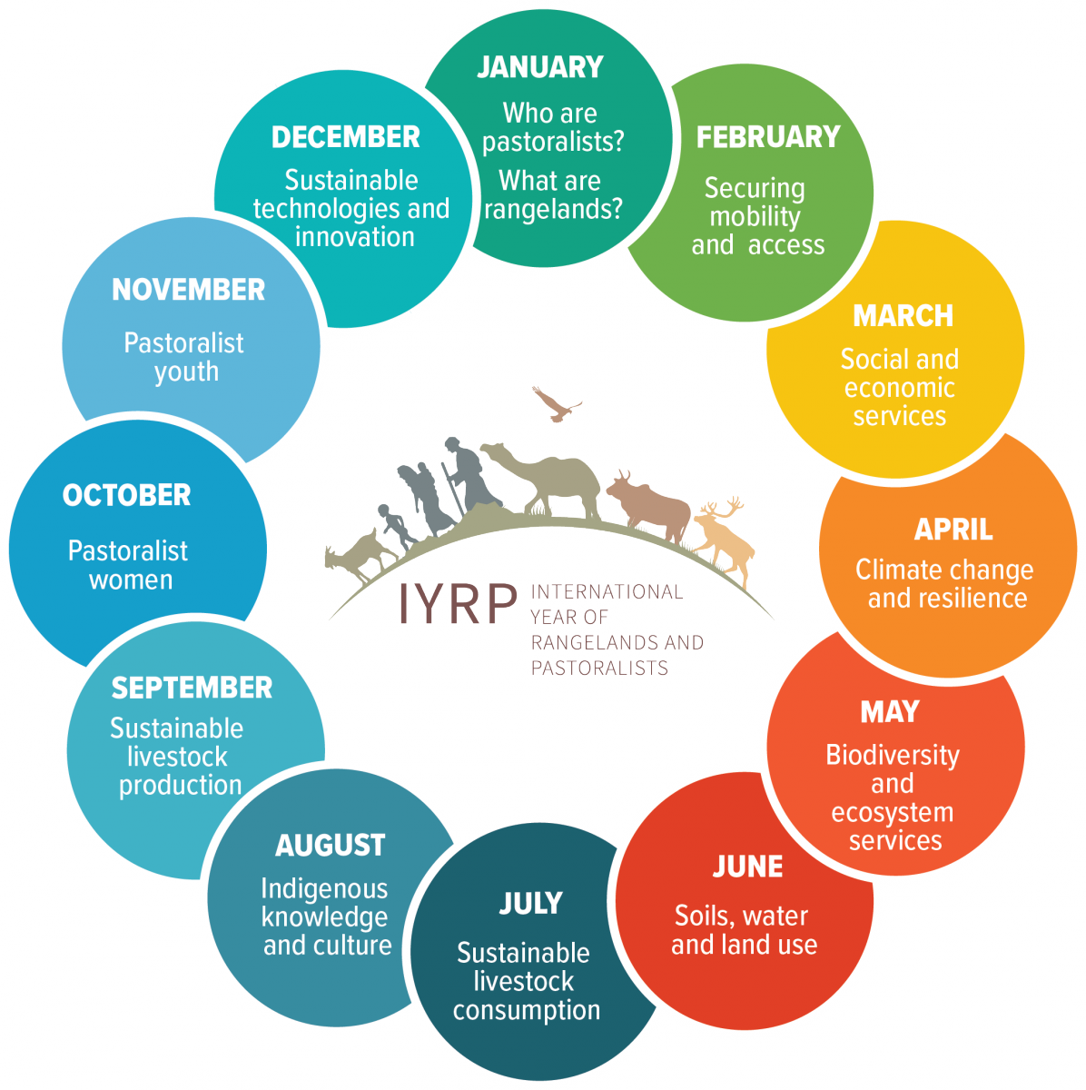
Possible monthly themes during the IYRP
For more information, please see:
https:///www.iyrp.info
https://globalrangelands.org/international-year-rangelands-and-pastoralists-initiative

