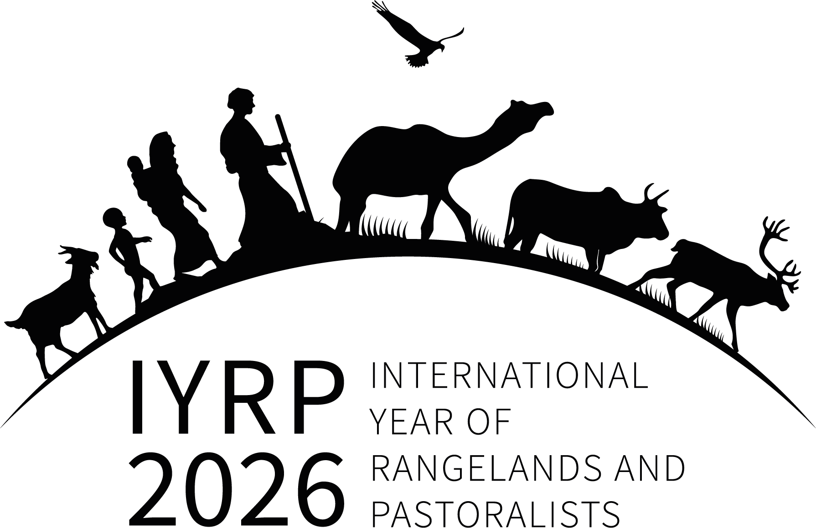
IYRP GCG 30 September 2022 meeting: Summary of Minutes

Chair of Meeting: Igshaan Samuels (Co-Chair of GCG)
Taking Notes: Maryam Niamir-Fuller (Co-Chair of GCG)

Participants:
Invited guests
- Batkhishig Baival, Mongolia Country Director, Sustainable Fiber Alliance (SFA)
- David Briske, Texas A&M University, USA
- Una Jones, CEO of SFA
- Ilse Köhler-Rollefson, LPPS, Germany
- Susi Vetter, Rhodes University, South Africa

GCG members:
- Harouna Abarchi, Ass. Nodde Notto, W/ Africa and Chair of West & Central Africa RISG
- Ann Waters-Bayer, Agrecol Association and CELEP, IYRP Global Communications Team
- David Borré, Pronatura Mexico and new Co-chair of North America RISG (NASG)
- Layne Coppock, Co-chair of North America RISG and Chair of the International Affairs Committee for the Society of Range Management (SRM)
- Andiswa Finca, Agric. Research Council & new Co-chair East and Southern Africa RISG
- Fiona Flintan, ILRI
- Jurgen Höth, outgoing Co-chair of North America RISG
- Ruijin Long, International Centre for Tibetan Plateau Ecosystem Management, Lanzhou University, China, and Chair of the East Asia RISG
- Bora Masumbuko, IUCN and member of the IYRP Working Group on UNCCD
- Munkhnasan Nasaa, Ministry of Food, Agriculture and Light Industry, Mongolia
- Ken Otieno, Reconcile of East Africa and co-chair of East and Southern Africa RISG
- D.K. Sadana, Chair of South Asia RISG
- Cecilia Turin, PastorAmericas, and Latin America RISG,
- Vivekanandan, Sustainable Agriculture, India, and South Asia RISG

Sent apologies: Jim O’Rourke (NASG), Serena Ferrari (West and Central Africa RISG), Barbara Hutchinson (IYRP Global Communications Team), Sarah MacDonald (Australasia RISG), Mounir Louhaichi (MENA RISG)

Unable to attend: Hasrat Arjjumend (CAM RISG), Hijaba Ykhanbai (CAM RISG), Anders Oskal (Arctic RISG), Chris Magero (IUCN), Dana Kelly (Australasia RISG), Pablo Frere (LAC RISG), Pablo Manzano (LAC RISG), Engin Yilmaz (Europe RISG), Olivier Maurin (Europe RISG), Abdelkader Bensada (UNEP), Gregorio Velasco-Gil (FAO), Khalid Khawaldeh (WAMIP), Hossein Badripour (MENA RISG)

Housekeeping:
The Chair welcomed the appointment of three new Co-chairs of the RISGs:
- David Borré to replace Jurgen Höth as Co-chair of NASG,
- New Co-chair of CAM RISG Hasrat Arjjumend
- Andiswa Finca to replace Igshaan Samuels as Co-chair of ESA RISG
- The IYRP logo has been slightly changed; it is a mirror image of the old one and the people and animals are now moving from left to right, which represents progress.

Agenda 1. Launch of the Rangeland Stewardship Council (RSC) - Batkhishig Baival

The RSC was launched at the Natural Fibre Connect Conference on 9 Sept 2022 and is led by the SFA. RSC is inviting collaboration from the IYRP GCG and ISG to build its structures and aims to be fully participatory as all growers, herders, and farmers will be involved in preparing the standards. Its vision is to prepare certification standards similar to the Forest Stewardship Council that would be global, covering all animal products, and connecting livelihoods, land degradation, biodiversity and climate issues into the product supply chain. Its focus will be on non-perishable animal products at this time and the RSC intends to build a traceability and assessment system.

The RSC was welcomed by the GCG. A certification of effective management and improved stewardship will impact positively on rangelands and animal product supply chains. Jürgen suggested looking at the global standard on working with birds in grasslands in North America and the approach should relate to the One Health concept. Bora informed that the IUCN/FAO participatory rangeland and grassland assessment methodology is now published and available here: https://doi.org/10.4060/cc0841en. Maryam mentioned the forthcoming IUCN/ILRI rangelands certification and standard setting project with GEF funding should be part of the RSC development process. A planning meeting will be held on Nov 30th 2022 in London to chart out the structures and operations of the RSC and the standards. A symposium at the SRM meeting in Boise (Feb 2023) will further engage with stakeholders on the development process.

- Recommendation = Una Jones to send a request for a dedicated meeting with IYRP GCG before the November 2022 meeting in London.

Agenda 2a. Update from the Working Group on Afforestation – David Briske & Susi Vetter

An overview of the draft Afforestation paper was presented, incl. how tree planting is seen as a panacea for climate mitigation, and that this has led to “greenwashing” and it impacts rangeland health. Some messages were distilled into a shorter “policy” paper which was reviewed by the GCG, and was submitted by the co-chairs for the public consultations of the Integrity Council of the Voluntary Carbon Markets (IC-VCM) in September 2022. The IC-VCM paper is available in all UN languages on the IYRP website. David suggested that more short policy papers should be developed and addressed directly at stakeholders involved with a) the Bonn challenge, b) the UN Decade on Restoration, c) and biodiversity conservation. There is growing evidence on how to restore and improve rangelands sustainably and these should be incorporated into existing guidelines, such as the FAO Grassland Manual and the Atlas of Forest Restoration Potential.

Igshaan reported on the FAO/COFO Working Group on Dryland Forests webinar that focused on transforming agri-food systems with trees. Igshaan told the meeting that the IYRP GCG is not anti-trees; but are against afforestation and deforestation, and we are for reforestation in ecosystems that naturally and historically are suited to it.

- Recommendation: Afforestation WG to work on other targeted papers; the paper for the UN Decade of Ecosystem Restoration should include a discussion of natural rangeland restoration (including the deliberate use of fire and grazing).

Agenda 2b. Update from the (WG) on the UNCCD – Bora Masumbuko

The UNCCD decisions and policy documents show a glaring gap for not covering rangelands and pastoralists, which is due to misperceptions and that pastoralists are often minorities in their countries. There are exceptions and some countries are working to reverse this gap by defining some of their targets for achieving Land Degradation Neutrality (LDN) accordingly. The
IYRP policy brief for UNCCD will raise awareness on these gaps with six key messages. These are: Recognizing and enabling mobility of animals as a viable management solution for rangeland health and restoration; Agreeing to strengthening and enforcing laws against indiscriminate conversion of rangelands; Adopting policies to promote the multi-functionality of rangelands; Opening markets for pastoralists and lifting barriers to their full and fair participation; Enhancing investment in nature-based rangeland restoration; and Improving the LDN targets by 2026. The co-authors aim to finalize a draft by mid-October for review by the larger WG and GCG. It would be used for preparing shorter policy papers for various UNCCD events. Several GCG Members welcomed the effort and Cecilia requested to be part of the WG.

Agenda 2c. Discussion of other Working Groups

Igshaan provided an update on attending the International Mountains Conference in Sep 2022 in Austria, and that a WG is preparing a policy paper on pastoralists and mountains in collaboration with the FAO Mountain Partnership Secretariat (MPS) and as part of the International Year of Sustainable Mountains Development in 2022. The key messages of the paper are: Protection of vertical transhumance; Access to markets, tourism, and other economic opportunities; and role of pastoralism in biodiversity conservation. Igshaan suggested that the FAO MPS perhaps could be a model for IYRP after 2026. Cecilia requested to be included in the IYRP Mountains WG.

Ann provided an update on a webinar organized by the Rural Water Supply Network and the International Water Management Institute on pastoralists’ water rights and governance in September 2022. There is a need to better clarify the challenges and dangers in sedentarization, challenges in securing water rights and governance, and how development efforts can continue to provide water security while supporting mobility of animals. UNCCD has been discussing the topic of “water diplomacy” which should also be relevant to pastoralists because of the transboundary nature of many livelihood systems.

Maryam provided an update on the idea of an IYRP WG on Biodiversity. IYRP need to contribute to the debate on Other Effective Area-based Conservation Measures to address concerns of those who do not believe that natural landscapes can become sustainable production landscapes. Maryam described a new opportunity that the GCG has in submitting a proposal for the Science for Nature and People Partnership (SNAPP) grant by 15 Dec2022 (https://awards.snappartnership.net).

GCG endorsed the creation of the Water and Biodiversity WGs. For the Biodiversity WG, we need to find people who understand and are engaged in the CBD processes and maybe those participating in Commission for Environmental Cooperation of North America.

Recommendations:
- Ensure attendees of CBD COP 15 in Montreal in December 2022, incl. the Cattlemen’s Association of Canada, are aware of the IYRP Side Event that was held in the CBD COP in Cancun and its declarations.
- Maryam to prepare a one-page concept note for the Biodiversity WG and Ann for the Water WG and share with the GCG for inputs.
- SNAPP application = Jurgen, Ken, Cecilia, to help Maryam, Igshaan and Ann to prepare 2-3 concept notes for sending for review by SNAPP by mid- or End-Oct.

Agenda 3. Update on Working Group for Outreach to pastoralists - Jürgen Höth

There has been no progress since the last GCG meeting and Maryam suggested the GCG to proactively start to leverage financing for pastoralists to participate in the IYRP 2026. The GCG thanked Jürgen for his efforts, and for his role as Co-chair of the NASG.

- Recommendation: Convene a dedicated RISGs chairs meeting to discuss financing and on how energize actions at the regional level in preparation for the SRM meeting in Boise.

Agenda 4. International Year of Camelids IYC (2024), and collaboration with the IYRP
- (Ilse Koehler-Rollefson)

At Ilse’s request, the agenda item was postponed but Cecilia to contact Ilse to discuss her and SA RISG involvement in the IYC

Agenda 5. Updates from the regions.

- Recommendation: All Co-chairs asked to send in a short briefing on their activities, which will also be included in the General Update to the ISG/General lists.

Agenda 6. AOB, and setting date for next meeting
There was no other business.

