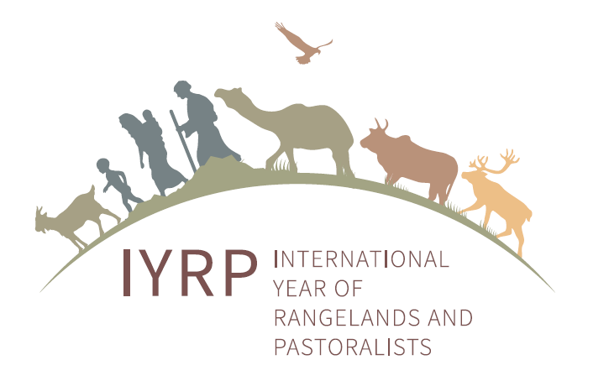

REPORT FROM
International Year of Rangelands & Pastoralists/Rangelands Initiatives
Open Space Session
GASL Conference – September 10, 2019 – 10:00am

Agenda – 30 Minute Session

With Special Thanks to the Government of Mongolia
https://globalrangelands.org/international-year-rangelands-and-pastoralists-initiative

Moderator - Livia Olsen, KSU Libraries and Rangelands Partnership - livia@ksu.edu

Status of the Mongolian Government Proposal to COAG/FAO Calling for a Designated International Year of Rangelands and Pastoralists (IYRP)
- Mr. Munkhnasan, Ministry of Food & Agriculture Light Industry, Mongolia
- Mr. Tumur-Uya Jambaltseren, State Secretary, Mongolia (unable to participate; travel issues)
- Tungalag Ulambayar, Saruul Khuduu Environmental Research & Consulting (Saruul Khuduu ERC), Mongolia - tungaa.sg@gmail.com
Welcome from Rangelands Initiative-Global and Rangelands Partnership
- Barbara Hutchinson, University of Arizona and Rangelands Partnership/Rangelands Initiative-Global – barbarah@cals.arizona.edu

Questions and Discussion

This brief session provided an opportunity to exchange information among interested parties. In spite of limited time, many people made suggestions and provided insights into home country situations. Highlights included:
- Mongolia has organized groups internally among three key ministries, NGOs, and others to form a National Task Force for the IYRP initiative. They have MOUs to work together and raise awareness. The IYRP Support Group also supports the effort through outreach such as a website, resource materials, posters, and holding side events at international meetings.
- Participants asked about available guidance on the process of supporting Mongolia’s proposal from ISP and National Task Force.
- Participants appreciated availability of information materials accessible from website.
- Discussed 1) informing/communicating among various in-country stakeholders, 2) creating a structure (Task force or Support group etc.) to move forward to get their government or organization support, and 3) obtaining formal support.
- There is a possibility to gain support from Argentina, Bolivia, Chile and Peru.
- Presidents of Uganda and Kenya are meeting soon to discuss pastoralist issues; may be an opportunity to gain a statement from those countries.
- U.S. State Department has a new pastoralist working group (USAID); contact Andrew Bisson for more information.

Follow-up Requests
- Need to have specific information on how to gain government support
- Need list of countries and organizations who have already submitted letters of support for the Mongolian Government
- Need explanation of why this effort is important
- Need specific details on what is needed from/how to go about gaining support from (1) governments and (2) organizations

Participants and invitees
- Carol Baldwin, K-State Research & Extension - carolbaldwin@ksu.edu
- Andrew Bisson, USAID – abisson@usaid.gov
- Barry Boubakary, Baobab Consulting Group, Burkina Faso - barry.boubakary@gmail.com
- Julian Chara, CIPAV, Columbia - julian@fun.cipav.org.co
- Martha Xochilt Flores - Fundación Produce Michoacán, Mexico - dramxfe@fupromich.com
- Pablo Frere, Red Pastoramericas, Redes Chaco and World Pastoralist Association (WoPA) Argentina - pablofrere@gmail.com
- Nitya Ghotge, ANTHRA, India - nityaowc19@gmail.com
- Margherita Gomarasca, VSF International - coordinator@vsf-international.org
- Elaine Grings, USAID/Washington State University - elainegrings@gmail.com
- Elizabeth Katushabe, PENHA-Uganda - elizabethkatushabe@yahoo.com
- Ilse Köhler-Rollefson, League for Pastoral Peoples and Endogenous Livestock Development, Germany/India - ilse.koehlerroll@googlemail.com
- Alexandre Ickowicz - alexandre.ickowicz@cirad.fr
- Carmen Jaquez, Mercy Corps - cjaquez@mercycorps.org
- Jacques Lasseur, INRA France - Jacques.lasseur@inra.fr
- Walter Oyhantcabal, Ministry of Agriculture, Uruguay - woyhantcabal@gmail.com
- Pablo Peri, INTA-UNPA-CONICET, Argentina - peri.pablo@inta.gob.ar
- Mel Poulton, ACRE New Zealand - acrechair@gmail.com
- Antonio Rota, Strategy and Knowledge Department, IFAD, Italy - a.rota@ifad.org
- Shirley Tarawali, ILRI - s.tarawali@cgiar.org
- Fabiana Villa Alves, Embrapa, Brazil - fabiana.alves@embrapa.br
- Jay Waldvogel, Dairy Farmers of America - jwaldvogel@dfamilk.com

