North American Support Group for the International Year of Rangelands and Pastoralists
Minute of the meeting held March 4th, 2021.
Prepared by Elena Dosamantes
Reviewed by Layne Coppock. Jürgen Hoth, Barbara Hutchinson and Barry Irving,

Participants

Barry Irving
Elena Dosamantes
Dale Weisbrot – Introduction – Retired, county, SRM
Jurgen Hoth
Robert Finck – Introduction – Targeted Grazing Company, SRM
Layne Coppock
Ray Smith
Aimee Roberson
Christian Artuso – Introduction – Canadian Wildlife Service
Arvind Panjabi
Elisabeth Huber-Sannwald
David Borré
Bill Payne
Barbara Hutchinson
Richard Forsman – Introduction – Retired, Forest Service(?)
Lia Biondo
Kelly Hopping
Larry Howery
Anne Gondor
Sheila Merrigan
Maryam Niamir-Fuller
Jeanne Pfander
Mary Jo Foley-Birrenkott
Mark Thorne
Hailey Wilmer

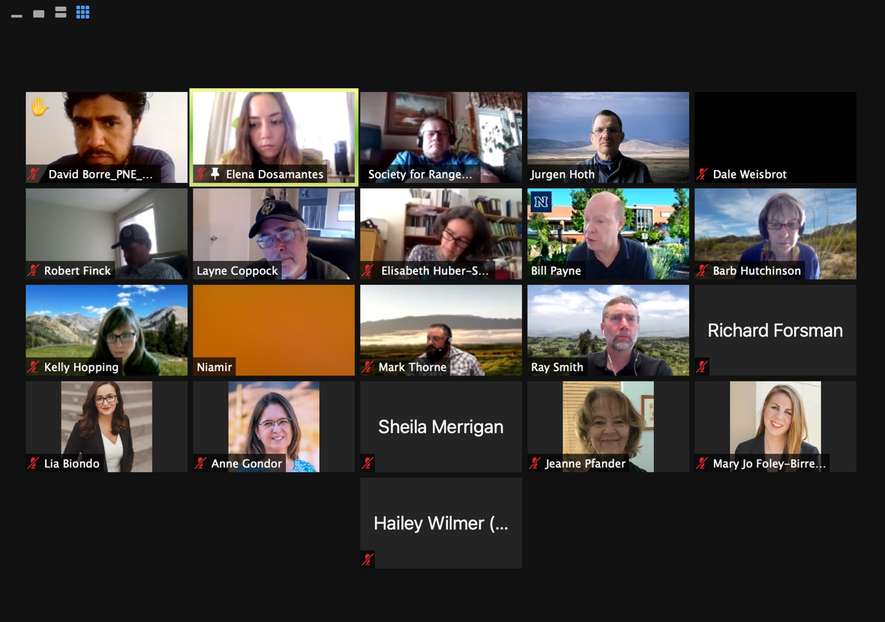

Agenda Items

1. Introductions, Additions, deletions, modifications to Agenda
2. Approval of Minutes from February 4.
Moved by: Jurgen Hoth
Seconded by:
3. Tri-National Discussion (by Jurgen Hoth)
A. Can-Mx-U.S. Trilateral Committee of Wildlife and Ecosystem Conservation & Mgmnt
- Next meeting scheduled for May 17-20
JH will gather and send directory of key representatives in each country. Commission for Environmental Cooperation (www.cec.org)
- Next Council meeting scheduled for June 26th
Representation:
- USA: EPA
- Mexico: SEMARNAT
- Canada: Environment Canada and Climate Change
- Grasslands Road Map (by Arvind Panjabu and David Borré)
- Draft roadmap
- 300 delegates.
- Website: https://www.grasslandsroadmap.org
    - Diagram: https://static1.squarespace.com/static/5e600ddcde3d9a12661c36a7/t/5f8359a377f3647b32d9cb40/1602443684540/Grassland+Roadmap+Diagram+v5.pdf
    - Executive Summary: https://static1.squarespace.com/static/5e600ddcde3d9a12661c36a7/t/5f8359a377f3647b32d9cb40/1602443684540/Grassland+Roadmap+Diagram+v5.pdf
- Small groups in Canada and Mexico (starting)
- Metrics group:
    - Stocking grasslands across the three countries
    - High risk vs low risk
    - What are healthy grasslands
- Get three countries to endorse
- Conversations with indigenous groups
Next steps:
- Jurgen Hoth: Future meetings, invite Arvind and David to present updates on Grasslands Road Map and invite CEC representative for an update on their grasslands program.
- Christian Artuso: Working groups involvement (Indigenous groups in Canada), communicate with him
- Maryam: Put information in North America folder of IYRP; use folder as part of outreach
- Barb: North American “folder” is now the IYRP page in a section called “resource”; minutes are being uploaded there too (https://iyrp.info/resources/322 - North American IYRP Resource)
- Christian Artuso: Participation from Black Feet groups (part of Grasslands Road Map)
- Arvind: Biannual “America´s Grasslands Conference” Conference inclusive of Americas, interested in reaching out to indigenous communities. https://www.nwf.org/grasslandsconference
- Maryam: Talk about indigenous involvement in every meeting, make it a point.
    - Indigenous Food and Agriculture Initiative University of Arkansas
    - First Nations Development Institute,
- Barb: (chat) https://nativeamericanrangelands.org/ - suggest reaching out to Diana Doan-Crider to participate in next meeting.

4. Mexico Status Report and Forward Plans (Jurgen Hoth)
- Elisabeth Huber-Sanwald: Sent letter to minister of agriculture in Mexico (SADER). Suggests working together with SADER and will also recommend that they send letter to Mongolian FAO ambassador in Rome
- Maryam: Direction on sending letters (FAO to at least be on paper) and information on General Assembly
5. US Status Report and Forward Plans (Layne Coppock)
- For February in the USA, IYRP had a strong presence at SRM. Thanks to Devan, Barb, and others. Also, Maryam conducted a very useful exploratory effort with USFWS and USAID people in Washington to clarify the approach needed to engage key US decision makers. Finally, today’s news headlines regarding the Vilsak confirmation as USDA Secretary reveal his priorities include climate change mitigation and empowerment of minority farmers. GOOD NEWS for IYRP!
- For March, the US subgroup needs to move quickly to get engagement rolling at least 90 days before next FAO conference in early July. There are 3 main objectives for March: (1) Clarify the networks and processes used by decision makers we must reach in the federal government; (2) clarify documents to be sent to key stakeholders, including a cover letter to VIPs, a general call-for-support one pager (already done), and a one-page brief justifying why IYRP matters for the USA; and (3) clarify a list of stakeholders outside of the federal government that will be contacted to generate support letters as evidence of enthusiasm for the IYRP to VIPs and others.
- Teams have been nominated to undertake the 3 objectives above; teams will be contacted soon by email from Layne with instructions. If people in the US subgroup of NASG are not contacted and want to participate, email Layne soon.
- SRM is vital to meet all 3 objectives. We especially need attention now to lists of higher-profile stakeholders under objective 3. Ray suggested organizations such as the American Forage and Grassland Council, State Forage and Grassland Councils, etc. Do we want fewer high-profile letters or more lower-profile letters?
- Other suggestions: U.S. Roundtable on Sustainable Beef, National Cattlemen’s Beef Association

6. Canada Status Report and Forward Plans (Barry Irving)
- Letters to Federal level Ministers (who are mandated to respond)
  - Minister of Environment and Climate Change, Minister of Agriculture and Agri-Food Canada, Minister of Foreign Affairs. Dale suggested including the Prime Minister’s Office as well.
- Draft letter sent to IYRP group for others to use if necessary
- One letter signed onto by 50 different organizations
  - Canadian Cattlemen’s Association, Native Conservancy of Canada as examples.
- Stay general in letters and use inclusive style writing at this stage.
- One letter with many signatories is the vision, but larger NGO’s free to send their own letter if they so wish.
- Maryam: List of stakeholders (Lia consolidated North America group), Yes, Barry developed the Canada list and others are adding to it. Will update with Lia as needed.
- Jurgen: Inclusion of indigenous groups? Barry to send Jurgen a link to an Indigenous leader with an interest in prairie grassland conservation and management.

7. Next meeting, Thursday April 1, 1-2:30 Mountain Time

